🚀 STEP 1: Launch EC2 (t2.micro)
Go to:
AWS Console → EC2 → Launch Instance
Configuration
Setting | Value
Name | studentname-vm
AMI | Amazon Linux 2
Instance Type | t2.micro
Key Pair | studentname-key
Security Group | studentname-sg
Inbound Rules | SSH (22) from My IP
Click Launch

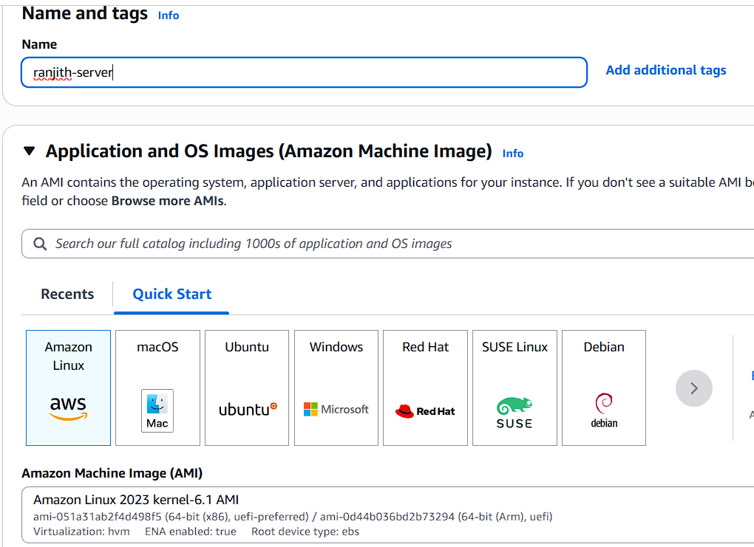
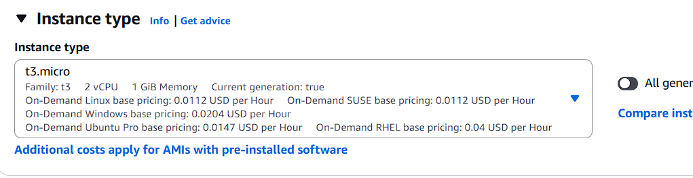

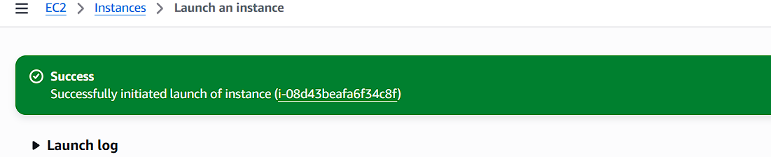

🔹 STEP 2: Connect to Instance
ssh -i studentname-key.pem ec2-user@<public-ip>
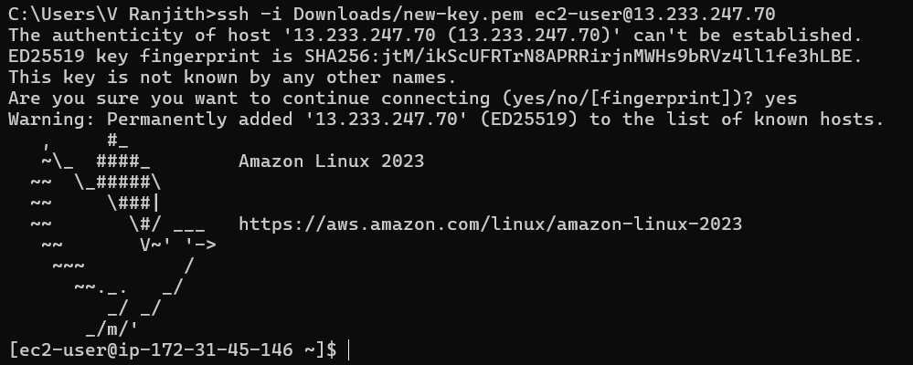

🔹 STEP 3: Check CPU Details
Lscpu

OR simple:
nproc
Expected output for t2.micro:
Resource | Value
vCPU | 1

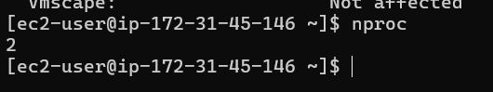

🔹 STEP 4: Check Memory
free -h
Expected output:
Resource | Value
Memory | 1 GiB

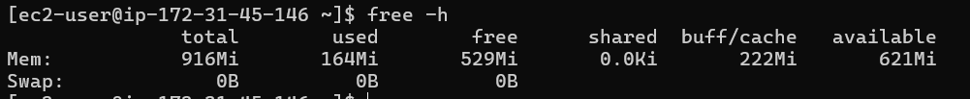

📊 Baseline Result (t2.micro)
Instance Type | vCPU | Memory
t2.micro | 1 | 1 GiB

🔴 STEP 5: Stop the Instance (Required)
Go to:
EC2 → Instances → Select studentname-vm
Click:
Instance State → Stop
Wait until state = Stopped
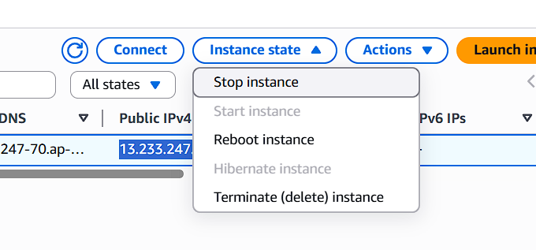

🔹 STEP 6: Change Instance Type
While instance is stopped:
Actions → Instance Settings → Change Instance Type
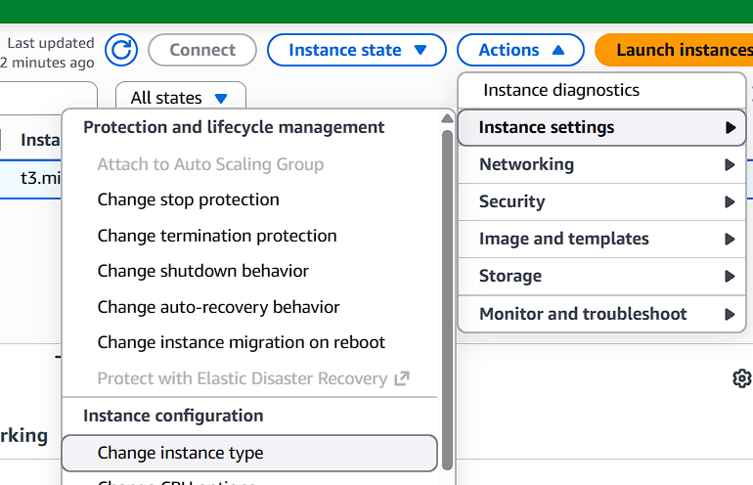
Choose one:
Option 1: t2.small
- 1 vCPU
- 2 GiB RAM
Click Apply
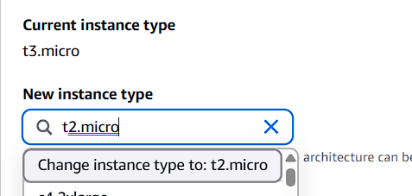

🔹 STEP 7: Start Instance
Instance State → Start
Wait until status checks = 2/2 passed
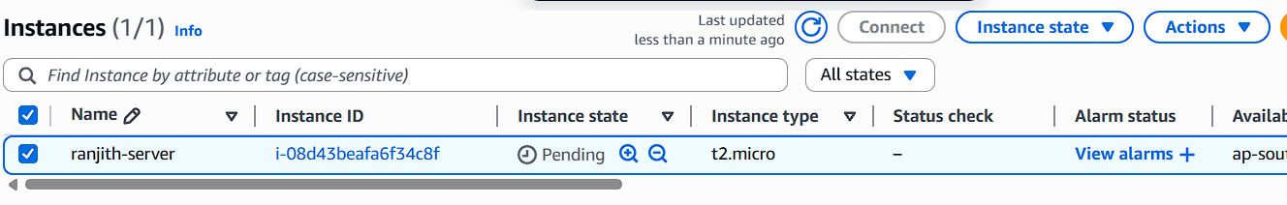

🔹 STEP 8: Validate CPU Again
SSH again:
ssh -i studentname-key.pem ec2-user@<public-ip>

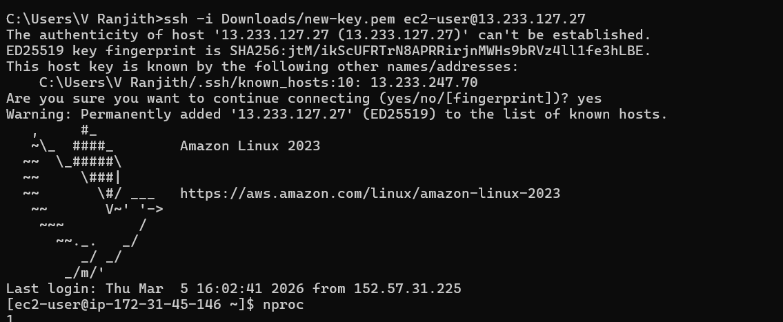
Check CPU:
Nproc

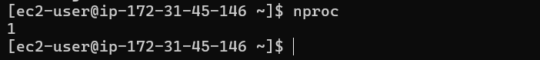

🔹 STEP 9: Validate Memory Again
free -h

